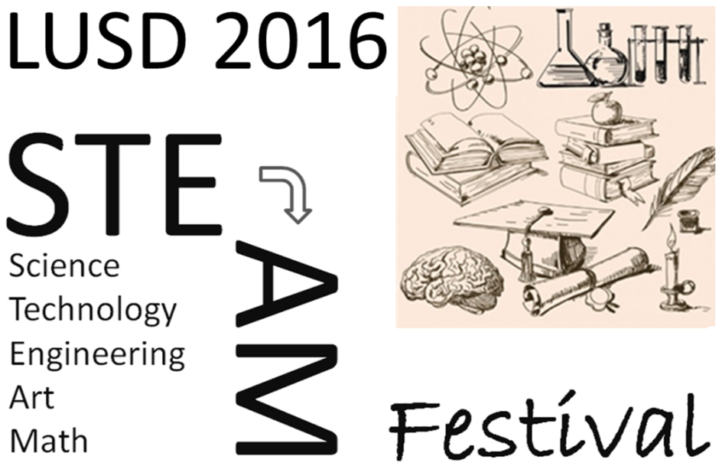
Booth Sign-up
Solicitation

What: Promote Science, Technology, Engineering, Art, & Math. Join us as we reach out to K-12 students and the Lompoc community with fun, engaging, hands on activities & display booths so students and families experience the motivational power of STEAM on education.

When: Friday, May 13th, 5 to 8 PM, and
Saturday, May 14th, 9 to 12 Noon
Where: Cabrillo High School Cafeteria & Surrounding Area.
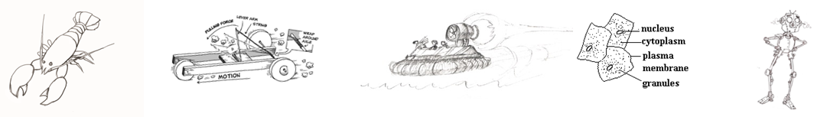

How: Sign-up for a time slot to host a booth (here) with an engaging STEAM activity targeting either elementary, middle school or high school students, or host a display booth that promotes STEAM + your club, school, company or business.

Contact: Paul Coski, coski.paul@lusd.org
www.CCSTEMExpo.org

