What: Promote Science, Technology, Engineering, Art, & Math. Join Lompoc community STEAM outreach with fun, engaging activities & display booths for everyone to experience.
When: Friday, May 29, 2015, 6 to 8 PM
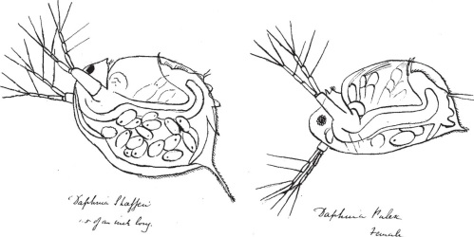
Where: Lompoc High School Cafeteria & Surrounding Area
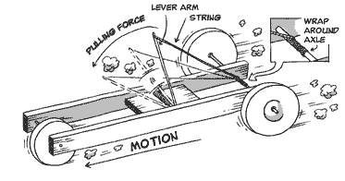

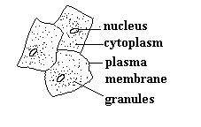
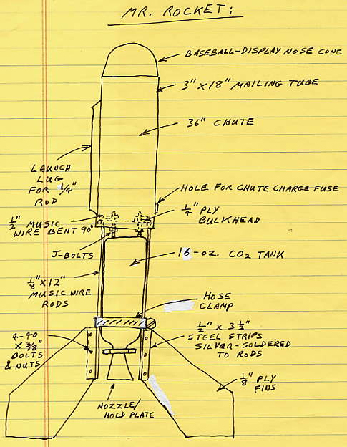
Sign-up for a booth to host a STEAM activity or display and promote STEAM + your club, school, company or business.
Contact: Paul Coski
coski.paul@lusd.org

